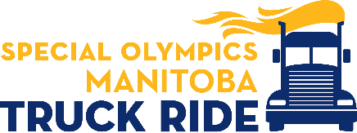

Special Olympics Manitoba Truck Ride
Saturday September 17, 2022
Sponsor Registration Form

Company Information

Please list main company contact information in this section.

Company:

Address:

City: State/Province Postal Code:

Phone ( ) Fax:

Company Contact Name: E-mail:

Desired Sponsorship Level: __________________________________________________________________

METHOD OF PAYMENT

Cash, Cheque, Visa or MasterCard.

Total Amount Due: Canadian $

Cheque enclosed made payable to Special Olympics Manitoba

Charge to: ( ) Visa ( ) MasterCard ( ) American Express

Account Number:
Expiration Date: _____ Security Code: ____

Card Holder Name: Signature:

Please return this page with payment to:

Special Olympics Manitoba
Attn: Jennifer Campbell
304 - 145 Pacific Avenue, Winnipeg, MB, R3B 2Z6
Or for credit card payments, email to: clangtry@specialolympics.mb.ca

2022 Sponsorship Opportunities

Gold $2000 +

- Use of statement, “Official Proud Supporter” on all company materials
- Media acknowledgement
- Company logo in post event Free Press Community Profile.
- Company logo on event banner and on trailer wrap of lead truck
- Company logo on sponsor signage
- Company logo on 2022 SOM Truck Ride commemorative t-shirts
- Company Logo on Website
- Sponsor recognition plaque
- Registration for 3 Trucks in the SOM Truck Ride

Silver $1000

- Use of statement, “Official Proud Supporter” on all company materials
- Program acknowledgement
- Company logo on event banner
- Company logo on sponsor signage
- Company logo on 2022 SOM Truck Ride commemorative t-shirts
- Company Logo on Website
- Sponsor recognition plaque
- Registration for one truck in the SOM Truck Ride

Bronze $500

- Program acknowledgement
- Company name on t-shirts & sponsor banner
- Company name on Website

