What is Draft an Athlete?

Draft an Athlete is an investment in your community, paving the way to a world where everyone is included. It’s about building partnerships between athletes involved in Special Olympics and the communities in which they live, train, and make us proud.

Why Should I Partner with Special Olympics Manitoba?

Special Olympics Manitoba is part of a global movement of inclusion and we are dedicated to enriching the lives of Manitobans with an intellectual disability through the transformative power of sport. We are changing the lives of Manitobans with an intellectual disability. With more than 3,000 athletes, volunteers and coaches Special Olympics Manitoba develops and delivers over 130 athlete-centered programs in all seven regions of the province.

Our athletes are thriving members of your community. With your support, we end discrimination against people with intellectual disabilities ensuring they can train, compete, socialize, and work in your community.

If you’re a fan of determination and inspiration, then you’re a fan of Special Olympics! Drafting an athlete is your opportunity to support a Special Olympics athlete in your community and become an integral part of their success.

Special Olympics Canada Winter Games – Thunder Bay 2020

This year, Team Manitoba is made up of 60 inspiring athletes who will represent our province in Thunder Bay, ON at the Special Olympics Canada Winter Games from February 25-29, 2020. This is a premier national event that will welcome over 1200 athletes, coaches, and mission staff from across the country to compete against one another in 8 sports, in the hopes of qualifying for Team Canada and the chance to compete at the 2021 World Winter Games in Sweden. The cost to send just one of our Provincial Team athletes to Thunder Bay is $1500.

How Will I Make a Difference?

- Provide an inclusive environment for our athletes to live, train and compete
- Provide support for sport science for Team Manitoba athletes
- Provide support for equipment, facility, transportation, and competition
- Unify your community, reveal champions, and change the world

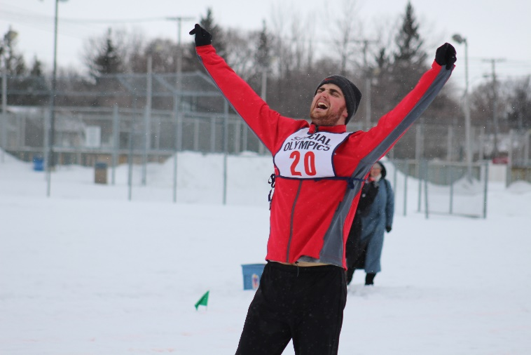

What do I get?

Donation -> Tax Receipt +
- Meet and greet opportunity with your athlete
- Thank you letter and picture from your athlete
- A tax receipt for the full amount of your donation

Sponsor -> No Tax Receipt
  - Meet and greet opportunity with your athlete
  - Thank you letter and picture from your athlete
  - Company name recognition in our annual partner thank you
  - Ability to use our logo as a Draft an Athlete Partner
  - Thank you mention on Special Olympics Manitoba social media

What do I give?

As much as you are able! No gift is too small.

On behalf of our athletes, coaches, staff and volunteers, we thank you in for considering a donation or sponsorship.

Please visit our website www.specialolympics.mb.ca to learn more about us.

I will touch base with you shortly to follow up on this proposal. We look forward to partnering with you!

Sincerely,

Melissa Suggitt
Manager, Regional Relations
msuggitt@specialolympics.mb.ca
204.925.5626

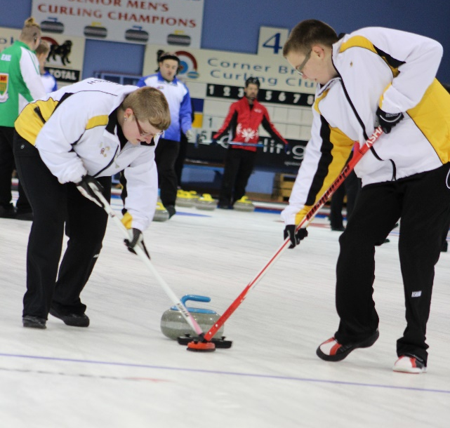

Business Name:
Contact Person:
Address:
City/Town: |  |  |  | Postal Code:
Contact Person:
Phone Number: |  |  |  | Fax Number:
Email Address:
If sponsor of a specific athlete, name of athlete
Cheque or Credit?  (please check one) | Cheque  (please enclose) |  |  |  | Credit
If Credit Card (please check one): | VISA |  |  | Mastercard |  |  |  | AMEX
Credit Card #: |  |  |  |  |  | Expiry Date:
Sponsorship Amount | $
Would you like a tax receipt? (please check one) | Yes |  |  |  |  | No

Please forward your donation/sponsorship form to:

Special Olympics Manitoba
304-145 Pacific Avenue
Winnipeg, Manitoba
R3B 2Z6
Attention: Draft an Athlete

